System Requirements Specifications for RoadTrip

Sponsor

Electrical, Computer, Software & Systems Engineering at Embry-Riddle Aeronautical University

Released **DATE**

Are We There Yet?

Contents

Revision History 3

1. Introduction 4

1.1 Purpose 4

1.2 Problem Statement 4

1.3 Scope 4

1.4 Team Information 4

1.5 Overview 4

2. Overall Description 6

2.1 Stakeholders 6

2.2 Product Perspective 6

2.3 Product Functions 6

2.4 Use Cases 6

3. Functional Requirements 6

3.1 Movement 20

3.2 Navigation 20

3.3 Challenge Completion 20

4. Non-Functional Requirements 20

4.1 System Size 20

4.2 Power Management 21

4.3 Start Method/Operation 21

5. Glossary 22

6. Appendix A 24

7. Appendix B 25

# Revision History

|  |  |  |
| --- | --- | --- |
| Date | Reason for Change | Version |
| 7 Sep. 2014 | Initial Draft | 0.1.0 |
| 9 Sep 2014 | In-class revision | 0.2.0 |
| 10 Sep 2014 | Added Overall Description | 0.3.0 |
| 12 Sep 2014 | Added Use Cases and Sequence Diagrams | 0.4.0 |

# Introduction

## Purpose

The purpose of this document is to define the system requirements of the robot put forth by Are We There Yet (AWTY) to compete in the 2015 Institute of Electrical and Electronics Engineers (IEEE) SoutheastCon student hardware competition. These requirements include the functional and non-functional requirements, system constraints, system interface constraints and standards compliance of the system. This document is intended for the customer of AWTY, the requirements engineering team for AWTY, the design, testing and quality assurance teams, as well as all other teams involved in the development and construction.

## Problem Statement

To create an autonomous robot to compete in the 2015 IEEE SoutheastCon student hardware competition.

## Scope

The system built by AWTY is intended to compete in the 2015 IEEE Southeast Con student hardware competition. The system is envisioned to complete four unique challenges:

* Correctly play Simon for 15 seconds
* Draw “IEEE” on an Etch-a-Sketch
* Twist one row of a Rubik’s cube 180 degrees
* Pick up and carry one playing card across the finish line

The autonomous system is intended to successfully complete the challenges outlined above within a time limit of five minutes. **NEED MORE**

The system built by AWTY is not intended to serve any other functions or fulfill any other purposes other than competing in the 2015 IEEE SoutheastCon competition.

## Team Information

|  |
| --- |
| Name |
| Michael Philotoff |
| Brian Powell |
| Alex Senopoulos |
| Brian Sterling |

## Overview

Section 1 of this document serves as introduction to the system designed by AWTY. Section 2 provides an overall description of the system, including stakeholders involved in the project, the functions of the system and proposed use cases for the system. Section 3 describes the functional and non-functional requirements of the system

The Glossary contains definitions of all industry and standard terms as well as ambiguous terms, used throughout this document. A table of acronyms and abbreviations is included in order to dispel ambiguity with any acronym or abbreviation used within this document. A picture of the course is included in Appendix.

# Overall Description

## Stakeholders

The following list describes the individuals and parties involved in, or that have a stake in, the development, productions and operation of RoadTrip.

* + 1. Team AWTY

As the development team has a vested interest as they will be graded on the completion of the system by the customers. Additionally, efforts should be made to apply principles and concepts learned while at Embry-Riddle Aeronautical University (ERAU).

* + 1. Dr. Barott, Dr. Seker and Jorge Torres

As customers of team AWTY, Dr. Barott, Dr. Seker and Jorge Torres are interested in the completion of the product as outlined in this document. Furthermore, Dr. Barott and Dr. Seker are interested in ensuring that the project meets the standards set forth by Department of Electrical, Computer, Software & Systems Engineering (ECSSE) at ERAU.

* + 1. ERAU

Since the University is an indirect sponsor of the project, any actions taken by the development team reflect directly back upon the University.

* + 1. ECSSE Department

As the direct sponsor of the project, the department is interested in making sure the project is delivered both on time and on budget.

* + 1. IEEE

As the sponsor of the competition for which the final system will compete in, the IEEE is interested in making sure that the final system complies with all competition rules and that the development team has conducted themselves in a manner befitting of a professional organization.

## Product Perspective

RoadTrip is intended to be an autonomous robot whose sole purpose is to compete in the IEEE 2015 SoutheastCon student hardware competition.

## Product Functions

RoadTrip is broken down into five major subsystems: (1) the line following subsystem, (2) the Simon subsystem, (3) the Etch-a-Sketch subsystem, (4) the Rubik’s cube subsystem and (5) the playing card subsystem. The purpose of these subsystems is to facilitate the requirements engineering process.

* 1. Use Cases

The following use cases demonstrate the intended operations of RoadTrip. The use cases outline the intended sequence of events as well as the procedures that will be followed in the event of a system failure.

Note: “*” indicates at any given time, during the use case.

* + 1. Use Case 1: Full Completion of the Course

Scope: RoadTrip

Level: User goal

Primary Actors: RoadTrip

**Stakeholders & Interests**

* **Team AWTY** - As the development team has a vested interest as they will be graded on the completion of the system by the customers. Additionally, efforts should be made to apply principles and concepts learned while at Embry-Riddle Aeronautical University (ERAU).
* **Dr. Barott, Dr. Seker and Jorge Torres -** As customers of team AWTY, Dr. Barott, Dr. Seker and Jorge Torres are interested in the completion of the product as outlined in this document. Furthermore, Dr. Barott and Dr. Seker are interested in ensuring that the project meets the standards set forth by Department of Electrical, Computer, Software & Systems Engineering (ECSSE) at ERAU.
* **ERAU -** Since the University is an indirect sponsor of the project, any actions taken by the development team reflect directly back upon the University.

**Preconditions**

* RoadTrip has been place in the 1’ x 1’ starting square on the Two-dimensional playing field.
* RoadTrip has been turned to the on position.

**Postconditions**

* RoadTrip crosses the finish line holding a single playing card.

**Main Success Scenario**

* RoadTrip waits for the red LED to turn off.
* RoadTrip starts line follows and makes turns based on which way the line is turning until the first challenge zone.
* RoadTrip completes the first challenge as described in Use Case: Simon Challenge.
* RoadTrip turns around and begins to line follow until the second challenge zone.
* RoadTrip completes the second challenge as described in Use Case: Etch-A-Sketch Challenge.
* RoadTrip turns around and beings to line follow until the third challenge zone.
* RoadTrip completes the third challenge as described in Use Case: Rubik Cube Challenge.
* RoadTrip turns around and beings to line follow until the fourth challenge zone.
* RoadTrip completes the fourth challenge as described in Use Case: Card Challenge.
* RoadTrip turns around and beings to line follow until crossing the finish line while holding onto a card.

**Extensions (Alternate Flows)**

*a. Roadtrip is in a bad state.

1. Roadtrip will backtrack last known good state.

2. Roadtrip shall proceed with the next steps to take.

**Frequency of Occurrence**

This use case will occur each time the system is placed within the 1’ x 1’ white square. During the competition this shall occur three times due to there being three rounds for each robot that is entered.

* + 1. Use Case 2: Simon Challenge

Scope: RoadTrip

Level: User goal

Primary Actors: RoadTrip

**Stakeholders & Interests**

* **Team AWTY** - As the development team has a vested interest as they will be graded on the completion of the system by the customers. Additionally, efforts should be made to apply principles and concepts learned while at Embry-Riddle Aeronautical University (ERAU).
* **Dr. Barott, Dr. Seker and Jorge Torres -** As customers of team AWTY, Dr. Barott, Dr. Seker and Jorge Torres are interested in the completion of the product as outlined in this document. Furthermore, Dr. Barott and Dr. Seker are interested in ensuring that the project meets the standards set forth by Department of Electrical, Computer, Software & Systems Engineering (ECSSE) at ERAU.
* **ERAU -** Since the University is an indirect sponsor of the project, any actions taken by the development team reflect directly back upon the University.

**Preconditions**

* RoadTrip has reached the Simon challenge zone.

**Postconditions**

* RoadTrip completes playing Simon for 15 seconds.

**Main Success Scenario**

* RoadTrip correctly identifies the challenge to be the Simon challenge zone.
* RoadTrip lines itself up with the Simon playing piece.
* RoadTrip pushing the start button located on the Simon.
* RoadTrip correctly identifies which colors and order the Simon has lit up.
* RoadTrip pushes each button in the order at which the Simon has lit up.
* RoadTrip repeats steps 4 and 5 until 15 seconds has passed.

**Extensions (Alternate Flows)**

*a. Roadtrip fails to respond or correctly push buttons in order to where Simon signals failure

1. Roadtrip shall restart at step 3 again and continue on with steps 4 and 5 (this process does not reset the 15 second timer).

**Frequency of Occurrence**

This use case will occur every time Roadtrip reaches and identifies the challenge to be the Simon challenge. During the competition this shall occur three times due to there being three rounds for each robot that is entered and this challenge shall occur once per round.

* + 1. Use Case 3: Etch-A-Sketch Challenge

Scope: RoadTrip

Level: User goal

Primary Actors: RoadTrip

**Stakeholders & Interests**

* **Team AWTY** - As the development team has a vested interest as they will be graded on the completion of the system by the customers. Additionally, efforts should be made to apply principles and concepts learned while at Embry-Riddle Aeronautical University (ERAU).
* **Dr. Barott, Dr. Seker and Jorge Torres -** As customers of team AWTY, Dr. Barott, Dr. Seker and Jorge Torres are interested in the completion of the product as outlined in this document. Furthermore, Dr. Barott and Dr. Seker are interested in ensuring that the project meets the standards set forth by Department of Electrical, Computer, Software & Systems Engineering (ECSSE) at ERAU.
* **ERAU -** Since the University is an indirect sponsor of the project, any actions taken by the development team reflect directly back upon the University.

**Preconditions**

* RoadTrip has arrived at the Etch-A-Sketch challenge zone.

**Postconditions**

* RoadTrip completes drawing ‘IEEE’ using the Etch-A-Sketch.

**Main Success Scenario**

* RoadTrip correctly identifies the challenge to be the Etch-A-Sketch challenge.
* RoadTrip lines itself up with the Etch-A-Sketch.
* RoadTrip twist the two knobs to draw ‘IEEE’ on the Etch-A-Sketch (Font and Size TBD).

**Extensions (Alternate Flows)**

*a. Roadtrip is in a bad state.

1. Roadtrip will backtrack last known good state.

2. Roadtrip shall proceed with the next steps to take.

**Frequency of Occurrence**

This use case will occur every time Roadtrip reaches and identifies the challenge to be the Simon challenge. During the competition this shall occur three times due to there being three rounds for each robot that is entered and this challenge shall occur once per round.

* + 1. Use Case 4: Rubik’s Cube Challenge

Scope: RoadTrip

Level: User goal

Primary Actors: RoadTrip

**Stakeholders & Interests**

* **Team AWTY** - As the development team has a vested interest as they will be graded on the completion of the system by the customers. Additionally, efforts should be made to apply principles and concepts learned while at Embry-Riddle Aeronautical University (ERAU).
* **Dr. Barott, Dr. Seker and Jorge Torres -** As customers of team AWTY, Dr. Barott, Dr. Seker and Jorge Torres are interested in the completion of the product as outlined in this document. Furthermore, Dr. Barott and Dr. Seker are interested in ensuring that the project meets the standards set forth by Department of Electrical, Computer, Software & Systems Engineering (ECSSE) at ERAU.
* **ERAU -** Since the University is an indirect sponsor of the project, any actions taken by the development team reflect directly back upon the University.

**Preconditions**

* RoadTrip has arrived at the Rubik’s Cube challenge zone.

**Postconditions**

* RoadTrip twisted a row of the Rubik’s Cube 180 degrees.

**Main Success Scenario**

* RoadTrip correctly identifies the challenge to be the Rubik’s Cube challenge zone.
* RoadTrip lines itself up with the Rubik’s Cube.
* RoadTrip twist one of the rows of Rubik’s Cube 180 degrees.

**Extensions (Alternate Flows)**

*a. Roadtrip is in a bad state.

1. Roadtrip will backtrack last known good state.

2. Roadtrip shall proceed with the next steps to take.

**Frequency of Occurrence**

This use case will occur every time Roadtrip reaches and identifies the challenge to be the Simon challenge. During the competition this shall occur three times due to there being three rounds for each robot that is entered and this challenge shall occur once per round.

* + 1. Use Case 5: Card Challenge

Scope: RoadTrip

Level: User goal

Primary Actors: RoadTrip

**Stakeholders & Interests**

* **Team AWTY** - As the development team has a vested interest as they will be graded on the completion of the system by the customers. Additionally, efforts should be made to apply principles and concepts learned while at Embry-Riddle Aeronautical University (ERAU).
* **Dr. Barott, Dr. Seker and Jorge Torres -** As customers of team AWTY, Dr. Barott, Dr. Seker and Jorge Torres are interested in the completion of the product as outlined in this document. Furthermore, Dr. Barott and Dr. Seker are interested in ensuring that the project meets the standards set forth by Department of Electrical, Computer, Software & Systems Engineering (ECSSE) at ERAU.
* **ERAU -** Since the University is an indirect sponsor of the project, any actions taken by the development team reflect directly back upon the University.

**Preconditions**

* RoadTrip has arrived at the Card challenge zone.

**Postconditions**

* RoadTrip has picked up a single playing card.

**Main Success Scenario**

* RoadTrip correctly identifies the challenge to be the Card challenge zone.
* RoadTrip lines itself up with the deck of cards.
* RoadTrip picks up a single playing card.
* RoadTrip continues to carry the playing card that was picked up.

**Extensions (Alternate Flows)**

*a. Roadtrip is in a bad state.

1. Roadtrip will backtrack last known good state.

2. Roadtrip shall proceed with the next steps to take.

**Frequency of Occurrence**

This use case will occur every time Roadtrip reaches and identifies the challenge to be the Simon challenge. During the competition this shall occur three times due to there being three rounds for each robot that is entered and this challenge shall occur once per round.

* 1. Sequence Diagrams
     1. Use Case 1

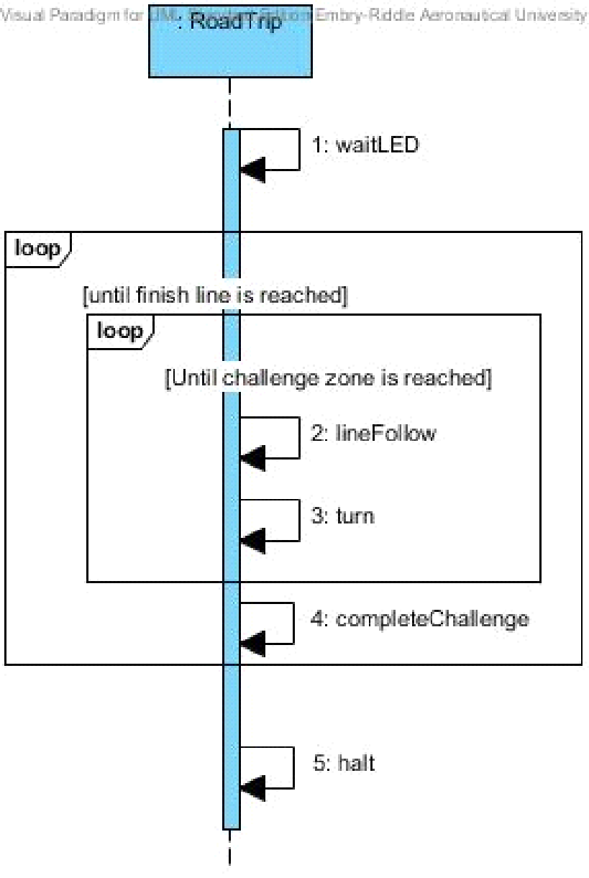For the Use Case: Full completion of the Course Sequence Diagram as shown in Fig. 1 below shows how the system will communicate with its self to complete the course for the IEEE SECon 2015 competition.

Fig. 1 Use Case: Full Completion of the Course Sequence Diagram

* + 1. Use Case 2

For the Use Case: Simon Challenge Sequence Diagram as shown in Fig. 2 below shows the steps RoadTrip shall take in order to complete the Simon challenge.

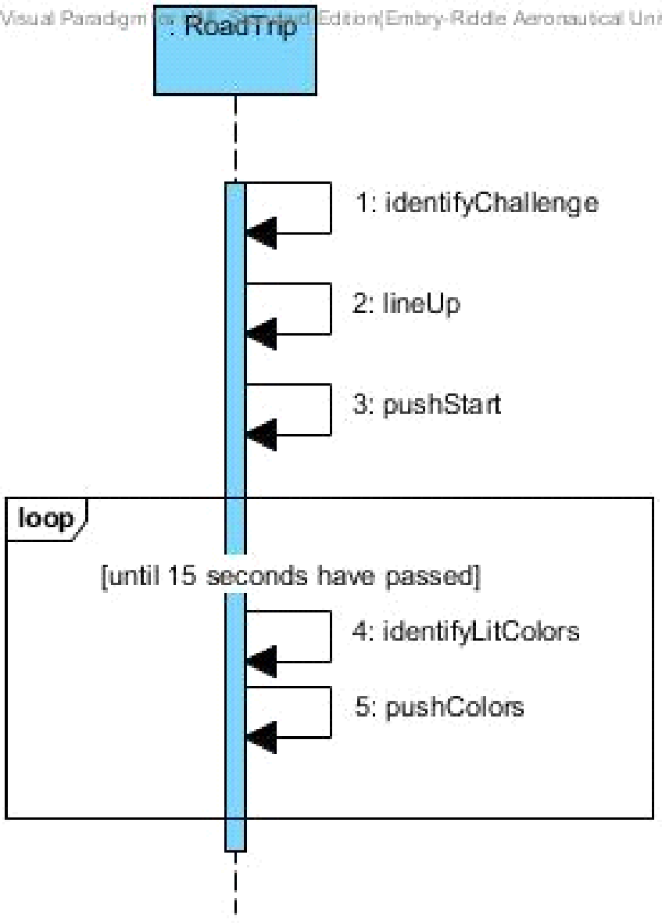

Fig. 2 Use Case: Simon Challenge Sequence Diagram

* + 1. Use Case 3

For the Use Case: Etch-A-Sketch Challenge Sequence Diagram as shown in Fig. 3 below shows the steps RoadTrip shall take in order to complete the Etch-A-Sketch challenge.

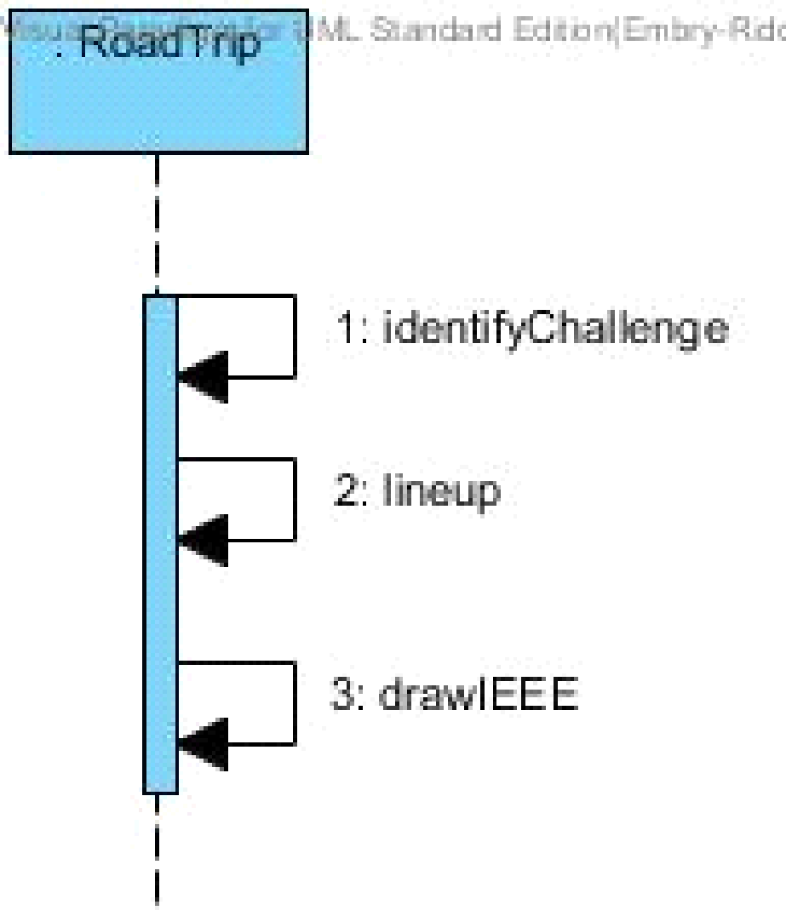

Fig. 3 Use Case: Etch-A-Sketch Challenge Sequence Diagram

* + 1. Use Case 4

For the Use Case: Rubik Challenge Sequence Diagram as shown in Fig. 4 below shows the steps RoadTrip shall take in order to complete the Rubik challenge.

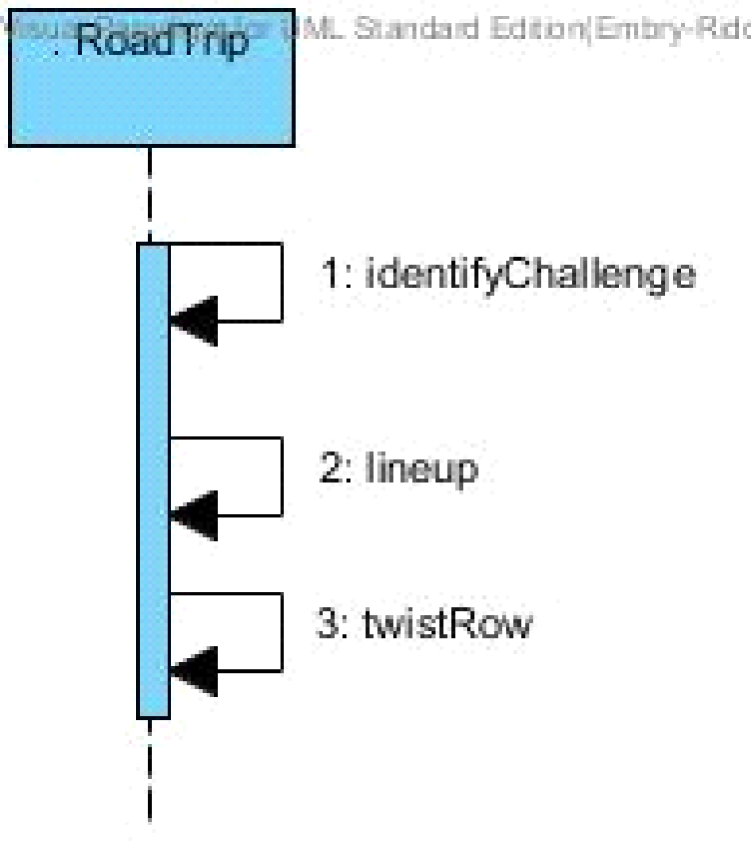

Fig. 4 Use Case: Rubix Challenge Sequence Diagram

* + 1. Use Case 5

For the Use Case: Card Challenge Sequence Diagram as shown in Fig. 5 below shows the steps RoadTrip shall take in order to complete the Card challenge.

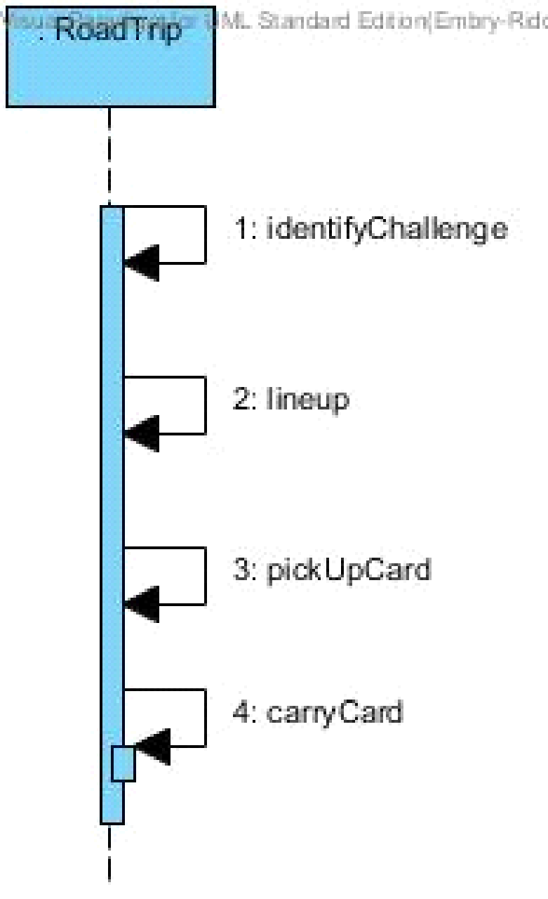

Fig. 5 Use Case: Card Challenge Sequence Diagram

# Functional Requirements

## Movement

* + 1. The system shall move in the two-dimensional playing field.
    2. The system shall identify red [RGB value TBD] LED in starting area.
    3. The system shall wait for red [RGB value TBD] LED to GO OUT (bad) before exiting starting area.

## Navigation

3.2.1 The system shall coordinate its movement along the scotch blue painters tape.

3.2.2 The system shall coordinate its movement back along the scotch blue painters tape if the system moves off of the scotch blue painters tape.

3.2.3 The system shall be able to identify the challenge areas in order to stop movement.

## Challenge Completion

* + 1. The system shall correctly identify the challenge zone upon arrival.
    2. The system shall line up with the challenge before attempting to complete the challenge
    3. The system shall play the Simon Carabineer (SKU:226CE810).
       1. The system shall play Simon Carabineer.
       2. The system shall plat Simon Carabineer for 15 seconds
       3. The system shall initiate Simon game by pressing the start button.
       4. The system shall correctly sense color blue [exact RGB values TBD] when illuminated on Simon board.
       5. The system shall correctly sense color red [exact RGB values TBD] when illuminated Simon board.
       6. The system shall correctly sense color yellow [exact RGB values TBD] when illuminated Simon board.
       7. The system shall correctly sense color green [exact RGB values TBD] when illuminated Simon board.
       8. The system shall not obstruct [TBR] Simon carabineer during play.
       9. The system will respond to Simon within [TBD] amount of time.
       10. The system will initiate Simon and play again upon failure to press the correct button in time.
    4. The system shall twist one row of a Rubik’s cube 180 degrees (SKU:DAD09D9E).
       1. The system shall not obstruct the Rubik’s cube during play.
    5. The system shall draw “IEEE” on a Pocket Etch-A-Sketch (SKU:FD79DD3F).
       1. The system shall rotate the knobs on the Etch-A-Sketch
       2. The system shall use [Font and Size, TBD] for drawing “IEEE”
       3. The system shall not obstruct the Etch-A-Sketch during play.
    6. The system shall collect a single playing card [Exact deck TBD].
       1. The system shall carry playing card across finish line.
       2. The system shall keep the card in a usable condition [TBD].

# Non-Functional Requirements

## System Size

* + 1. The system size shall occupy a space no greater than 1’ x 1’ x 1’ within the starting area and the finishing area.

## Power Management

* + 1. The system shall operate for a minimum of three course rounds each having duration of five (5) minutes, on one battery life.

## Start Method/Operation

* + 1. The system shall have a clearly indicated power switch.
    2. The system shall operate completely autonomously after being powered on.
    3. The system shall maintain contact with the plywood board at all times.

# Glossary

|  |  |  |
| --- | --- | --- |
| Entry | Definition | Aliases |
| SoutheastCon | SoutheastCon is the annual IEEE Region 3 Technical, Professional, and Student Conference. It brings together Computer Scientists, Electrical, and Computer Engineering professionals, faculty and students to share the latest information through technical sessions, tutorials, and exhibits. It is the most influential conference in Region 3 for promoting awareness of the technical contributions made by our profession to the advancement of engineering science and to the community. As usual, attendance and technical program participation from areas outside IEEE Region 3 are encouraged and welcomed. IEEE Region 3 encompasses the southeastern United States and includes the states of Alabama, Florida, Georgia, areas of Indiana, Kentucky, Mississippi, North Carolina, South Carolina, Tennessee, Virginia and the country of Jamaica |  |
| ERAU | Embry-Riddle Aeronautical University |  |
| IEEE | IEEE is the world's largest professional association dedicated to advancing technological innovation and excellence for the benefit of humanity. IEEE and its members inspire a global community through IEEE's highly cited publications, conferences, technology standards, and professional and educational activities.[3] |  |
| Obstruct | SECON rules state that the system cannot obstruct any obstacle [1]. This is to say that the challenge must always be visible and audible to the judges. |  |
| Autonomous | Undertaken or carried on without outside control [2]. |  |
| Two-dimensional playing field | The two-dimensional playing field is the plywood board where the competition is being held on. The system must maintain contact with the board at all times. |  |
| Usable Condition | SECON rules state that the playing card must be left in a usable condition [1]. This means the card must be in one piece and identifiable at the completion of the challenge |  |
| Starting Area | A one foot by one foot area on the two-dimensional playing field marked by scotch blue painters tape [1]. |  |
| Course Round | A span of five minutes during which the system is expected to complete the 4 challenges [1]. |  |
| Challenge Zone | The 1ft. x 1ft. areas where each of the specific challenges will be placed along the course. |  |
| Line Up | The system will position itself so the appendages can properly reach the challenges | Lines Itself Up |

# Appendix A

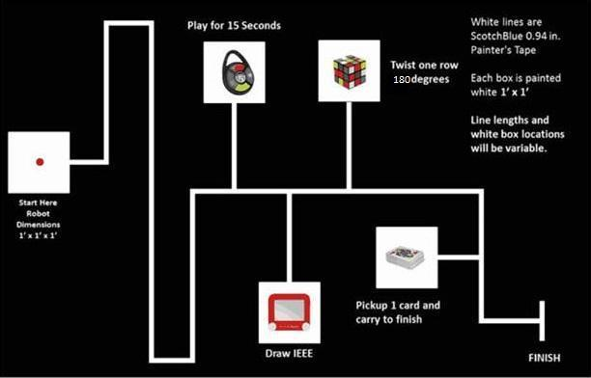

# Appendix B

# References

[2] Autonomous - Definition. (2014). Retrieved from <http://www.merriam-webster.com/dictionary/autonomous>

[3] "IEEE About IEEE." *IEEE*. N.p., n.d. Web. 12 Sept. 2014.